**Exploring Netflix Globally with Tableau Title Distribution and Country Insights**

**Problem Statement:**

ABC Company aims to leverage Tableau to analyze global Netflix content distribution and country-specific trends. By exploring the distribution of titles across different regions, the project seeks to uncover insights into viewer preferences and content availability. The goal is to provide interactive visualizations that offer a comprehensive understanding of how Netflix content is distributed worldwide, shedding light on cultural influences and market dynamics driving viewing habits. Through this analysis, ABC Company intends to gain actionable insights to inform decision-making, optimize content strategies, and enhance the viewer experience.



**Prerequisites:**

* Basic understanding of Data Analytics

[What Is Data Analytics? - An Introduction (Full Guide)](https://youtu.be/yZvFH7B6gKI?si=jD37tQzKJH1vl56A)

* Awareness of the lifecycle of a Data Analytics Project

[A Beginners Guide To The Data Analysis Process](https://youtu.be/lgCNTuLBMK4?si=a_J79oNSQIGNuNlH)

* Understand Tableau Interface- [Link](https://www.youtube.com/watch?v=oIw8xJ1Fy3w)
* Download Tableau Desktop-[Link](https://www.tableau.com/products/desktop/download)

**Objective:**

An objective is a specific, measurable, and time-bound goal or target that an individual or organization aims to achieve. Objectives are typically set to guide actions and decision-making towards desired outcomes. They are often a part of broader goals and help to clarify what needs to be accomplished within a certain timeframe. Objectives should be realistic, achievable, and relevant to the overall mission or purpose, providing a clear direction for efforts and resources.

**Task:**

* Visualize the count of Netflix titles to understand the overall distribution and volume of

available content.

* Determine the total number of countries where Netflix titles are accessible to gauge the platform's global reach and expansion.
* Analyse the count of Netflix titles by country and rating to identify geographical and content preference patterns, aiding in strategic decision-making for content acquisition and distribution.

**Dataset**: [Link](https://www.kaggle.com/datasets/arnavvvvv/netflix-movies-and-tv-shows)

**Solution Development Procedure:**

* In Tableau, the "Connect" option refers to the initial step in the data visualization process where users connect to various data sources to import data into Tableau for analysis and visualization.

* When you select the "Connect" option in Tableau, you are presented with a variety of data connection options.

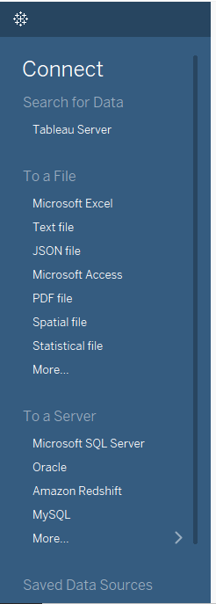

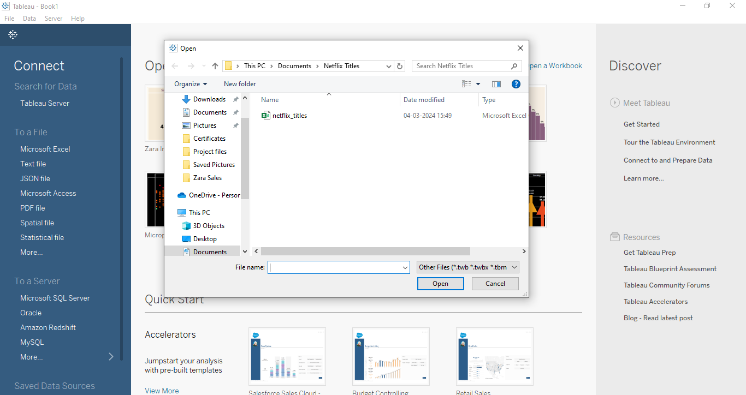

* Once we load the data into the Tableau.

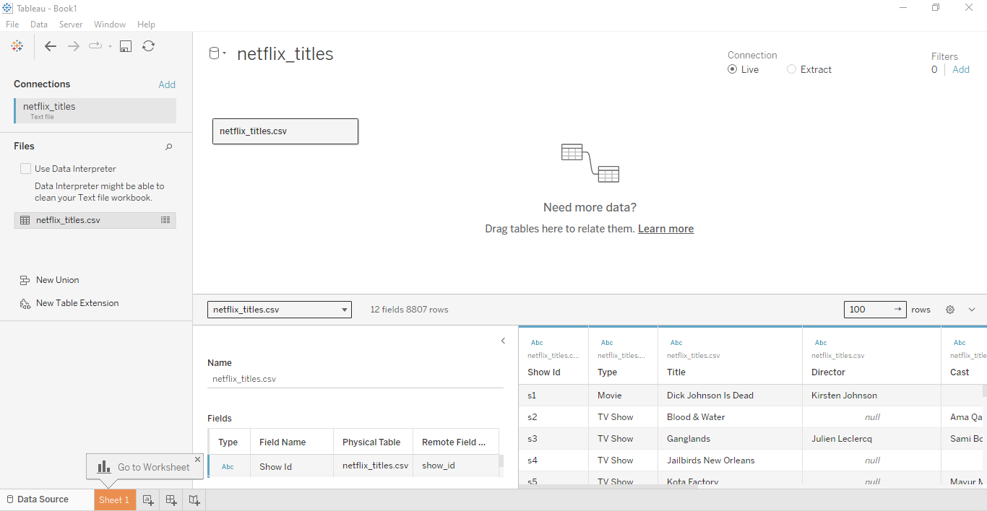

* Now , we proceed to create dashboard for Netflix Worldwide: Analysing Title Distribution and Country Trends.
* To create the dashboard, which will satisfy the task above, we consider the followingcolumns:
  + Count of Netflix Titles by Country
  + Count of Netflix Titles by Rating
  + Total Countries to have Netflix
  + Count of Netflix Titles
  + Distinct Count of Duration
* We have created the dashboard which is presented below.

**Dashboard:**

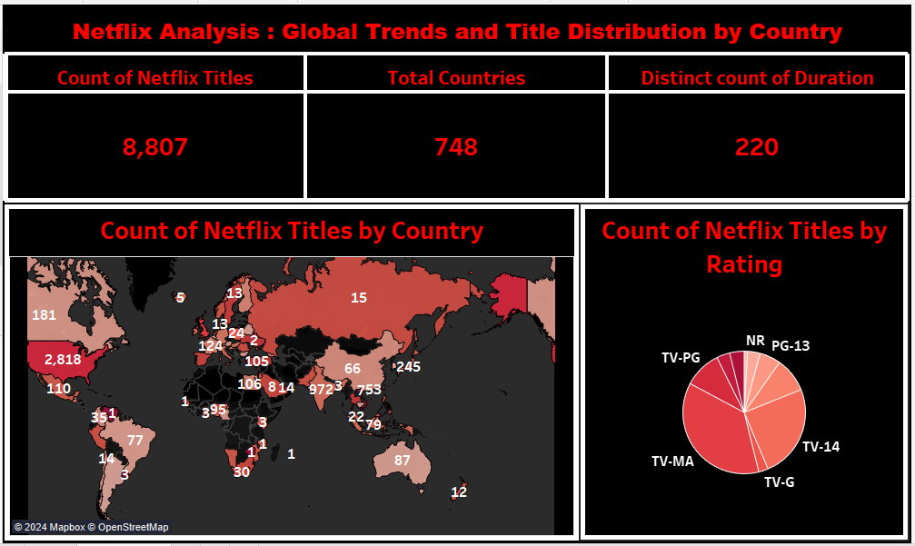

**Explanation Video:** Link

Note: The explanation video for the dashboard is in the link above.

**Insights:**

Insights refer to valuable and meaningful understandings or perceptions gained from analysing data, information, or experiences. They provide deeper understanding, clarity, or revelation regarding a particular subject or situation.

* Netflix boasts a remarkable presence in 748 countries, affirming its extensive global reach and commitment to providing entertainment worldwide.
* The platform offers a staggering 8,807 titles, showcasing its diverse library catering to a wide range of viewer preferences and interests.
* With 220 distinct durations among its titles, Netflix ensures versatility in content length, accommodating varied viewer schedules and preferences with options ranging from short-form series to full-length films.

**Conclusions :**

Conclusions are logical deductions or decisions drawn from observations, evidence, or analysis. Conclusions are often based on the findings or results of a study, experiment, or evaluation, and they aim to summarize key insights or outcomes. Effective conclusions should be supported by evidence, logical reasoning, and critical thinking, leading to well-informed decisions or actions.

* Netflix's presence in 748 countries, coupled with a library of 8,807 titles and 220 distinct durations, underscores its global dominance and widespread accessibility, catering to diverse audiences worldwide.
* The extensive content offering reflects Netflix's commitment to providing a diverse range of entertainment options, ensuring subscribers have ample choices to suit their preferences and interests.
* Analysis of the duration variations among titles suggests Netflix's dedication to offering a personalized viewing experience, aligning with the diverse schedules and preferences of its global audience, thereby enhancing user satisfaction and engagement.